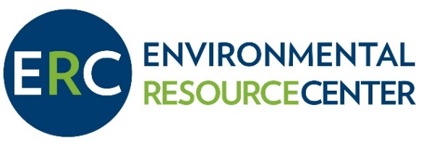
Job Title: Programs Coordinator
Supervisor: Executive Director
Date: August 10, 2020
Available: Immediately until filled

About the Environmental Resource Center: The mission of the ERC is to provide education and inspire action to cultivate a healthy environment in Idaho’s Wood River Valley.
The Environmental Resource Center (ERC) was founded in 1993 by a group of volunteer environmentalists dedicated to the health and vitality of Blaine County.
Today, we are a small – but mighty – nonprofit working to tackle large issues on a local scale. Our environmental education programs reach people of all ages and provide individuals with opportunities to gain the knowledge, tools, and confidence needed to become stewards and leaders. Our community initiatives work to reduce waste and toxins, which ensure healthy soils and water, while galvanizing the community to protect our natural resources.
About the Position:
The Programs Coordinator, working closely with the Executive Director and the Director of Education, is responsible for identifying, organizing, implementing and evaluating the ERC’s diverse environmental community service programming. They will work in all aspects of marketing efforts, volunteer coordination, and when needed, will facilitate youth and community engagement programs.

The Programs Coordinator is a grant-funded, hourly position (25-40 hours / week). The funded period runs from September 2020 – January 2021, with an option of extension depending on grant funding. This position is supervised by the Executive Director and works in close conjunction with the Director of Education.

Essential Job Duties:
- Answers and/or delegates inquiry calls and emails.
- Oversees the well-being of ERC facilities, equipment, and technology, and maintains office supplies.
- Maintains internal lists for staff of rotating office duties such as cleaning.
- Assists in all communication including electronic monthly newsletters, promotional materials, website and social media, and press releases.
- Collaborates with staff to develop, execute, and improve all aspects of ERC communication to enhance engagement, maintain brand integrity and affinity, and increase community and donor support.
- Develops, coordinates, markets, administers and evaluates volunteer recruitment, coordination, acknowledgement, and retention.
- Assists with the implementation, facilitation, and evaluation of youth and community programs when needed.
- Acts as a positive representative of the ERC while communicating with the community via phone, email, or in person both on and off-site.
- Manages volunteers, interns and staff to assist, when necessary and appropriate, in program development, implementation and evaluation.
- Works in and promotes a positive staff culture with a team-player approach.

Requirements

- Bachelor’s degree in a relevant field or equivalent experience. Knowledge, experience, and a passion for environmental science and/or education is important.
- Ability to use current computer technologies, including Microsoft Office, WordPress, Gmail, Constant Contact, and social media platforms.
- Excellent written and verbal communication skills, with experience and comfort in public speaking.
- Ability to handle pressure in a professional manner and manage multiple projects/deadlines efficiently.
- Ability to work in a dynamic, team-oriented work environment that, at times, demands flexibility, and requires clear communication and immediate resolution of conflict.
- Demonstrated interest and creativity in marketing and community outreach.
- Experience leading and managing volunteers and program staff.
- Ability to deal effectively and personably with a variety of people, including members, directors, staff and the general public.
- Willingness to conduct programs and lead groups in outdoor settings for several hours and in inclement weather, as well as work some weekends and odd hours to fulfill job requirements, particularly during high season.
- Work is performed primarily in an office environment using a desktop computer. Work requires, on occasion, moderate physical effort including but not limited to: lifting 30-40 lbs and climbing/descending steps. Must be able to work and teach for multiple hours at a time, lead groups in outdoor settings and work in inclement weather.

The Environmental Resource Center is an Equal Opportunity Employer. Qualified applicants are considered for employment without regard to age, race, color, religion, sex, national origin, sexual orientation, disability or veteran status.

To Apply:
Please send a cover letter and resume to:
Lindsay Mollineaux
ERC Executive Director
lindsay@ercsv.org

